Diabetes Treatment Analysis
Luke Mallory

The purpose of this experiment was to compare and evaluate the effectiveness of three separate diabetes treatments: Metformin, Rosiglitazone, and lifestyle adjustments. A treatment was recorded as successful if it effectively reduced progression to full diabetes for pre-diabetic patients. Overall, the observed Rosiglitazone success rate was approximately 61.3%, the Metformin success rate was approximately, 48.4%, and the lifestyle adjustment had an approximately 53.4% success rate. In order to evaluate the differences between the three treatments, 10,000 bootstrapping samples were created to estimate the densities and distributions of average outcomes for all groups, as well as calculate the average treatment effect (ATE) for all three comparison groups.

Initial Bootstrap KDE Plots
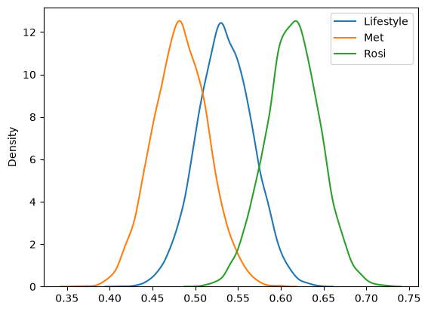

Initial Bootstrap ECDF Plots
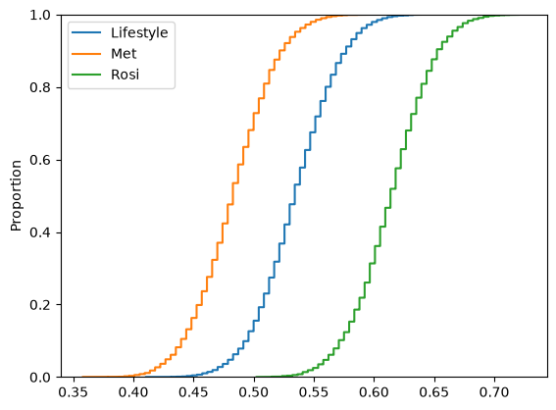

The bootstrapping KDE and ECDF were first estimated and plotted to examine the resulting densities and distributions of treatment success rates. As can be observed from the initial plots, all three treatments’ bootstrapped success rate estimates follow a roughly normal distribution. It appears again that the Rosiglitazone treatment is the most effective, having the bulk of the distribution fall in the 0.60 – 0.65 range. Rosiglitazone is again followed by lifestyle changes, and Metformin, which are distributed around the 0.50 – 0.55 and 0.45 – 0.50 ranges respectively.

Comparison Confidence Intervals
Comparison | 90% CI | 95% CI | 99% CI
Lifestyle vs. Met | [-0.026, 0.129] | [-0.039, 0.142] | [-0.065, 0.167]
Lifestyle vs. Rosi | [-0.152, -0.007] | [-0.170, 0.010] | [-0.199, 0.036]
Rosi vs. Met | [0.058, 0.208] | [0.041, 0.221] | [0.006, 0.247]

Following the plots, confidence intervals were calculated to evaluate the statistical significance of the differences between treatments. The resulting intervals strongly suggest that the Rosiglitazone treatment is the strongest overall treatment. The Rosiglitazone treatment had a positive effect over the Metformin treatment at all three confidence levels. The Rosi treatment also had a positive effect over the Lifestyle treatment at the 90% confidence level. While the results were not conclusive enough to reject the null hypothesis that the average difference between the Rosiglitazone and lifestyle changes treatments was equal to zero at the 95% and 99% confidence intervals, its dominance over the Metformin treatment and statistical significance at the 90% level suggest that it is the strongest overall treatment. However, the lack of statistical significance at the 95% and 99% confidence levels should be a sign to use discretion when picking treatment. There is not enough evidence to determine which treatment had a stronger effect between the met and lifestyle treatments, as 0 is present on all three confidence intervals, suggesting that the difference is not statistically significant.

